Airfix McDonnell-Douglas DC-9 Conversion
By Paul Hackmann

Background

The DC-9 family series of airliners was designed to capture the short-field and short- to intermediate-range routes that proliferated throughout the United States. At the time of design these routes were dominated by either piston-engined, such as the Martin 404 series, or turbo-prop airliners, such as the Lockheed Electra.

The DC-9 first flew on February 25, 1965, entering service as the DC-9-10 with Delta Airlines in December 1965. The production line for the DC-9 was operated for 18 years, finally producing a total of 976 airplanes to various airlines throughout the world. There were five versions of the DC-9 produced, differing in fuselage length, wingspan or engines. Additionally, the DC-9-10 series lacked leading edge slats and has only one over-wing emergency wing exit per side. These versions were:
Series | Wingspan | Fuselage Length | Length from Main Gear to Nose | Length from Main Gear to Tail | Engine
DC-9-10 | 89.4 ft | 92.1 ft | 51.3 ft | 40.8 ft | JT8D-7
DC-9-20 | 93.3 ft | 92.1 ft | 51.3 ft | 40.8 ft | JT8D-9
DC-9-30 | 93.3 ft | 107.0 ft | 60.8 ft | 46.2 ft | JT8D-15
DC-9-40 | 93.3 ft | 113.4 ft | 63.7 ft | 46.7 ft | JT8D-15
DC-9-50 | 93.3 ft | 121.3 ft | 68.5 ft | 52.8 ft | JT8D-15

Within each series there was some minor variations base on seating arrangements or access doors. Additionally, the -51 had strakes added to either side of fuselage just below and forward of the galley and entrance doors.

In 1980 the -50 fuselage was widened and re-engined. The result was re-designated the MD-80 series. This series includes the -81, -82, -83 and -88. Production for the MD-80 series concluded in 1999. The entire DC-9 and MB-80 series were powered by Pratt & Whitney JT8D engines. In 1993 the MD-90 was developed featuring a more advanced flight deck that includes electronic flight instrument system, a full-flight management system, a state-of-the-art inertial navigation system and LED displays for engines and systems. Additionally the MD-90 is powered by International Aero Engines V2500 fanjets.

Eastern began operating first DC-9, DC-9-14 N8901E, in April 1966. Eastern received delivery of an additional fourteen DC-9-14s (N8902E-N8915E) between May and February 1967. Aircraft registrations N8901E-N8907E were retired or sold by 1970, but the rest continued on until 1979. One -14 (N8910E) was damaged in a non-fatal training accident on Feb 9 1979.

In January 1967 Eastern took possession of the first of 75 DC-9-31s (N8916E-N8990E) it was to receive between that January and May 1973, the bulk of which arrived during 1968. Of these most all continued flying in Eastern colors through January 1991. Of these four were written off in accidents.
Registration | Date | Accident Synopsis
N8948E | 12/28/1987 | Hard landing experienced at Pensacola Regional during thunderstorm. A/C fuselage broke just aft of wing. No fatalities.
N8961E | 5/18/1972 | While parked at Atlanta International, fire broke out destroying cabin, cockpit and baggage area. No fatalities.
N8967E | 11/27/1973 | A/C departed wet runway at Akron-Canton Regional and impacted dirt bank. No fatalities.
N8984E | 9/11/1974 | While in IFR conditions, A/C impacted ground while on approach to Douglas Municipal in Charlotte, NC. 71 Fatalities.
Eastern also operated 9 DC-9-32s that were transferred from Continental Airlines in January 1990.

The final version that Eastern owned was the -51. These were purchased in blocks as follows:
Registration #s | Date
N991EA-N999EA* | July – November 1977
N401EA-408EA | May – November 1978
N418EA | Oct 1980
N419EA | Aug 1980
N420EA | Nov 1981
N421EA | Feb 1982

*Note: N991EA-N999EA were re-registered as N406EA-N417EA in October 1978.

These also continued in Eastern service until January 1991. No -51’s were lost during their 14 year operations with Eastern.

Markings
All of the DC-9 series in Eastern service were painted in the two-tone blue “Hockey Stick” scheme. The -14 had either a white upper fuselage or were all natural metal, depending on when it went through rework. All -51s were natural aluminum.
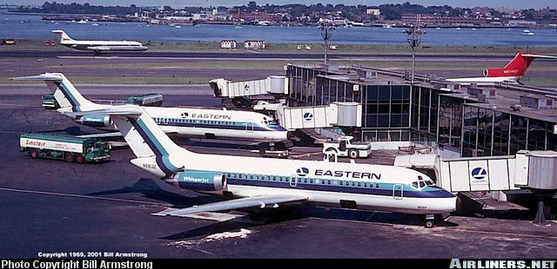
Photograph courtesy of Bill Armstrong of Airliners.Net

The aircraft depicted above is DC-9-14 N8913E, which was received in December 1966 and retired in December 1979. This photograph was taken at La Guardia in 1969. Of note are the APU exhaust stains on the fuselage above the right engine and the single over-wing emergency exit. This particular aircraft was acquired by Northwest in 1986 and was operating with that fleet as late as August 2003.

DC-9-51
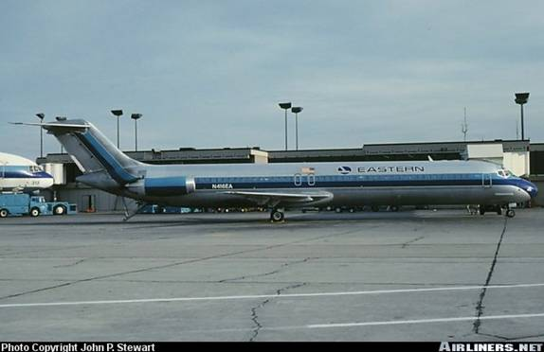
Photo courtesy of John P. Stewart of Airliners.Net

The DC-9-51 shown above is N416EA, received in October 1978 and operated until January 1991. In this photograph taken In Detroit in October 1978, it is in the natural aluminum scheme. In this photograph, the -51’s distinctive strakes can be seen just below and forward of the galley entrance. Also, note the rear stairway is extended. This aircraft was acquired by TWA in September 1993.

Building the Kit(s)
In order to do this conversion, I pretty much had to do what McDonnell-Douglas did with the real airplane. First I had to get my hands on two of the only available DC-9 kit in 1/144 scale, the Airfix DC-9-30s. Fortunately, this kit was recently re-released in KLM markings and was available at Venture Hobbies. The other thing I had to get was to get markings for either two DC-9-30’s (Liveries Unlimited) or get 1 set of old Microscale EAL DC-9-51 decals and one Liveries set. Fortunately the catalyst for this whole project was the acquisition of the old Microscale sheet through eBay. The Liveries Unlimited sheet was purchased through Hannant’s.

The next order of business was to figure out how much I had to remove from one -30 to make a -14 and how much I had to add to the other to make a -51. To make a -14 from a -30, roughly 10 scale feet needs to be removed from in front of the wing and about 5 scale feet needs to be removed from aft of the wing. Conversely to make a -51, you have to add 8’(2,32cm in front of the wing and 6’(1,54cm) aft of it. Since the kerf of the razor saw is about 1 scale foot, I made it easy on myself by rounding so that I used 10’(2,54) and 5’(1,27). This equates to .8” and .4” respectively that has to be either added or subtracted to each fuselage. For the -14, I also had to remove 2’ from either wingtip or .16”.
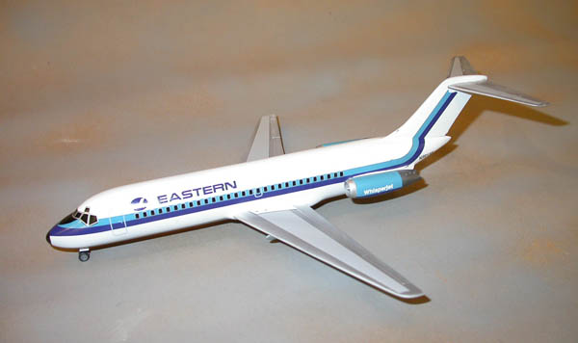

So as to minimize the number of pieces I had to slice up fuselages, I laid out two right sides from each kit onto a piece of graph paper. Using a scribing tool I marked an arbitrary reference line at the same point on each fuselage half both forward and aft of the wing. I cut the first fuselage half into three pieces, placing my cuts on the reference line. On the other kit’s fuselage, I made my cut .8” forward of the reference line in front of the wing and .4” aft of the line behind the wing. By taking that longest center section and mating it to the tail and forward sections of the first kit, I ended up with a fuselage that measured 1.2” longer than the -30 fuselage. I essentially added .8” to the forward section and .4” to the aft. By taking the shorter center section from the first kit and adding the tail and forward section from the second I ended up with the -14 fuselage, since its now 1.2” shorter. Using the pieces I had just cut as reference, I carried out the same surgery on the left fuselage of each kit. Some organization is required here as the number of fuselage parts increases from 4 to 12 and you don’t want to glue the wrong pieces together.

The process of reassembling the fuselage halves now begins. Making sure I kept the correct pieces for the lengthened fuselage in one place, I glued all the respective pieces for the right side of the -51 together. To make sure that the fuselage did not have any weak areas where it had been re-attached, I added a Plastruct I-beam the entire length of the fuselage along the window line. I also added several strips of plastic along the perimeter of each cut. I did the same to the left fuselage half. Both halves were taped, flat side down to a pane of glass to ensure that they didn’t warp or curl while drying. While they were drying a similar process was done on the remaining fuselage pieces to form the -14 fuselage.

A couple of days later, when everything had a chance to dry and set, I removed each fuselage half from the glass and ran the mating surfaces across a sheet of sandpaper laid on a flat surface. Once that was done, the fuselage halves were attached so as to have a complete -51 and -14 fuselage. Super glue was used to fill all of the window openings in both fuselages and a bead was applied to each seam as well. Since I was going to represent the cockpit windows with decals, I went ahead and filled the nose with lead shot, poured some super glue in to hold the shot in place and glued the kit supplied clear windshield in place on both fuselages. When dry, all areas were sanded smooth starting with 320-grit and proceeding down to 12000-polishing grit. Both fuselages were sprayed with a light coat of primer and any imperfections were filled and sanded again. One last step remained on the -51 and that was to add the two nose strakes. I once again used my scribing tool to make a slot on each side of the fuselage. This slot was made deep enough and just wide enough to accept a plastic strake made from a thin strip of plastic. Having completed both fuselages, I turned my attention to the wings.

For the -51, no change to the wing is necessary. The kit wings were assembled and attached to the -51 fuselage. The -14 was a different matter, the wing being 2’ shorter that the -30 kit’s and it does not have leading edge slats. I cut as near to .16” as I could off of each wingtip, reshaped the wing and leading edge, added a new wingtip light fairing and sanded the raised representations of the leading edge slats off. The newly shortened wings were added to the -14 fuselage. A littler filler was required on both kits. I used Bondo Scratch filler for this as its very thin and can be smoothed with a finger tip. Some light sanding and polishing about an hour later completed assembly. The completed main bodies were washed one last time and placed aside to dry. While the models were drying, I assembled the four JT8 nacelles. All require some sanding to eliminate a prominent seam line along the mating surfaces.
While painting a model airlines isn’t as complex as a four-tone camo military jet, it does have its own challenges as good gloss white and natural aluminum finishes are difficult to obtain. I began with the -14 model by spraying the fuselage and engine pods with an undercoat of light grey, following with a coat of Model Master Flat White. This laid the base for two light coats of Model Master Classic White, which dries to a glossy finish. Allowing this to dry for a couple of days, the fuselage was masked off according to my references in preparation for the aluminum surfaces. Three coats of SNJ Aluminum were applied and buffed with SNJ Buffing Compound. A similar procedure was followed on the horizontal stabs and replacement gear doors. The kit’s doors are too thick and I made new ones out of plastic card. All of the remaining parts were painted as necessary. At this time, the -14 was placed aside and work began on the -51.

Since the -51 would be over-all aluminum, I sprayed the entire model, including engine pods, horizontal stabs and replacement gear doors, with gloss black. Again, three light coats of SNJ and buffing were applied to the model once the gloss had dried. All of the remaining parts were painted as needed.
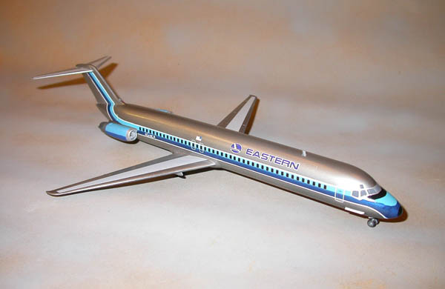
Now that both models had been painted, I began decaling. I began with the -51. The right-side decals went on with no problems. The left side came apart just forward of the engine pod and I had to do a little patchwork. The Microscale decal sheet supplied the fuselage Hockey Stick and Eastern logos, so I ended up having to purchase DC-9 window, door and Wing coroguard decals through Hannant’s. Also, the decals do not wrap around the nose, so the colors there have to be matched and either sprayed or brushed. I elected to spray and carefully masked the portioned decaled with post-it notes. A little weathering was applied and a coat of clear semi-gloss was done over the whole model to protect the markings. Finally all of the remaining pieces were attached and I called this one done and went to the -14.

A similar process was followed in decaling the -14, except that Liveries Unlimited supplies not only EAL markings but all of the necessary door, window, coroguard and walkway decals. As these were for a -30 I had to shorten the fuselage stripe, but this was easily done. I did have to make up the registration number, because the one supplied was white and would go on the blue stripe just forward of the nacelle. On the scheme I chose, the registration number went on the tail cone just aft of the nacelle. After all of the decals had been applied, a clean up was done, weathering applied and a final light coat of semi-gloss clear was done. The model was completed with the addition of the remaining subassemblies.

Wow, that completes the DC-9 fleet. They look pretty cool lined up on the shelf, each representative of a different style of paint scheme beginning in the mid-60’s to the late ‘80’s. This was a fun and challenging project, also a nice opportunity to stretch my modeling capabilities a little. Now it is on to finishing up the 727-100, 757, L-1011 and A300. Then its starting the Connie that Steve picked up for me at OK City, planning the 707 to 720 conversion, looking for a 1/72 scale Heller 749 in order to use the EAL decals that Dick gave me, wondering if the resin Martin 404 is worth the effort and praying that Minicraft will come out with a DC-7.

For those of you keeping score, models thus far completed:
DC-3 (Minicraft)
DC-9-14 (Airfix)
DC-9-30 (Airfix)
DC-9-51 (Airfix)
Electra (Minicraft)
727-200 (Airfix)

Do not stand at my grave and weep.

in 1/144 is it 19,93 mm ahead of wing and 16,66 mm aft of wing.
I'm german and use the metric system you just have to convert this in the U.S.system.
So you just have to cut almost 2 cm forward and deleate 1,66 cm rear from the fuselage, add the MD-87 tail - that's it! Wings and engines are the same as on the "long" MD's.

