How to build the best paper airplane in the world
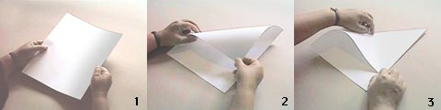
1. Start with an ordinary sheet of 8 1/2" x 11" - 21.6 x 28 cm (U.S.standard writing paper size). The exact size is not important, it should be rectangular and not square. The paper should be at least 20 Lb. bond or copy paper.
2. Fold over the left hand corner as shown.
3. Crease
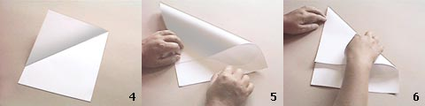
4. Result
5. Fold over the right hand corner.
6. Crease
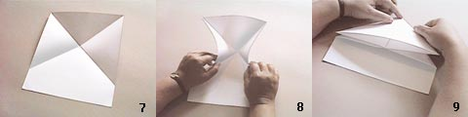
7. Result
8. Carefully close in the sides as shown.
9. Fold down the center line from front to back.
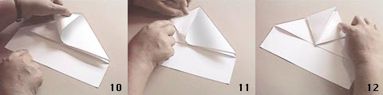
10. Fold the resulting left hand tip up as shown.
11. Crease along the bottom edge.
12. Repeat the same procedure on the right section.
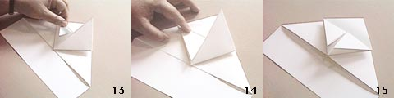
13. Fold the left hand point back.
14. Crease
15. Mirror the same folds on the right panel.
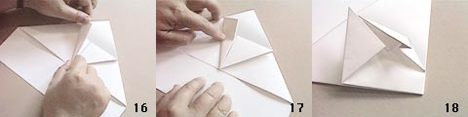
16. Bend the left panel as shown.
17. Crease from back to front only 2/3 of the way.
Note: I have received a large number of requests for clarification of steps 17 and 18. For detailed instructions of steps 16, 17 and 18, go to detailed instructions. For additional help go to the animation to view an animated sequence of these folds. This is for users of browsers that support GIF animation such as Netscape Navigator 2.0b5 and later, or Internet Explorer. If you are using a web browser that does not support GIF animations, you will only see the first or last frame in the animation. You can also view a Flash animation if your browser is equipped with a Flash plug-in.
18. Study photos 18 and 19 carefully. These folds are difficult to describe. Try to duplicate them as shown in the photos.
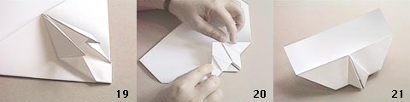
19. Mirror the folds on the right.
20. Turn the plane over and fold the point back and crease as shown.
21. Turn the plane over again. The result should be similar to the photo.
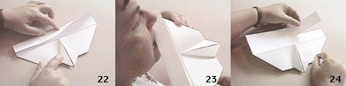
22. Crease wing as shown.
23. Moisten the crease with your tongue. Do this slowly and carefully or you could receive a painful paper cut on your tongue.
24. Carefully tear off strip of paper. Save the strip of paper because you are going to need it to make the tail.
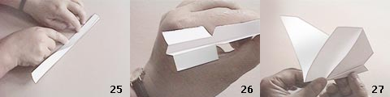
25. To make the tail, fold down the center of the strip of paper to form a trough.
26. Tear as shown to form control surfaces. The folds should be parallel with the bottom of the trough.
27. Fold wings up.
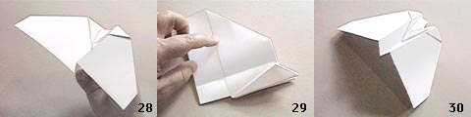
28. Fold the right wing down as shown in photos 28 and 29. Take special care to angle this fold in such a way so that the leading edge of the wing is slightly higher than the trailing edge.
29. Study this photo and you will see that the fold is not exactly parallel with the trough at the bottom but slightly angled as described in photo 28.
30. The plane should look like this at this point.
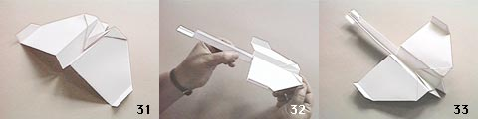
31. Bend the wingtips up.
32. Insert tail into slot under wing.
33. Finished at last!
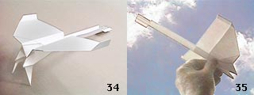
34. Aircraft shown with landing gears down. Note: the craft does not fly as well with the gears down.
35. Ready to fly! - IMPORTANT: For instructions on how to fly the model airplane, go to How to fly it.

